**POSSIBLE ARRANGEMENT OF ZONES**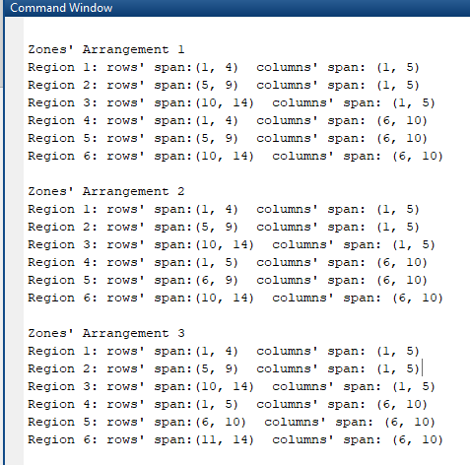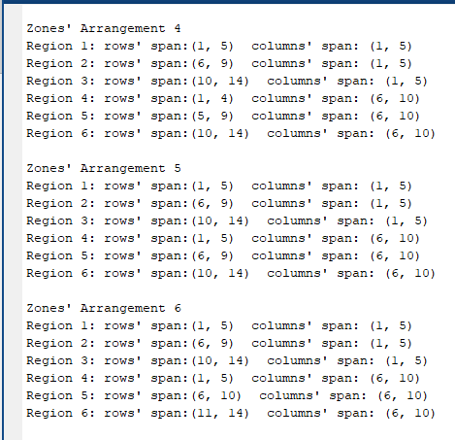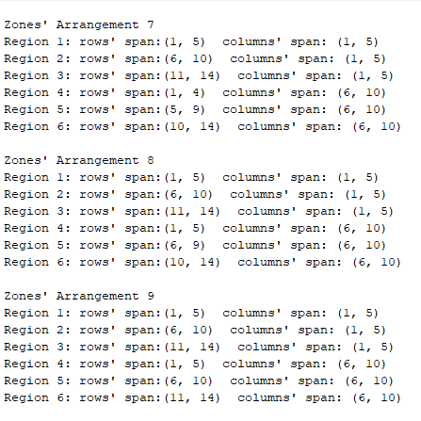

**ROOM: KITCHEN**

**BEST ARRANGEMENT OF ZONES and BEST LED POSITION:**

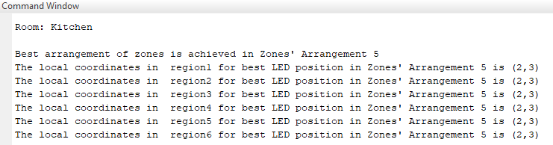

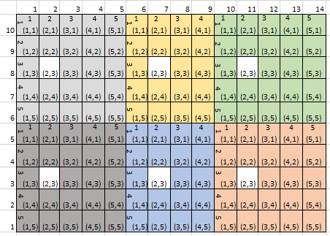

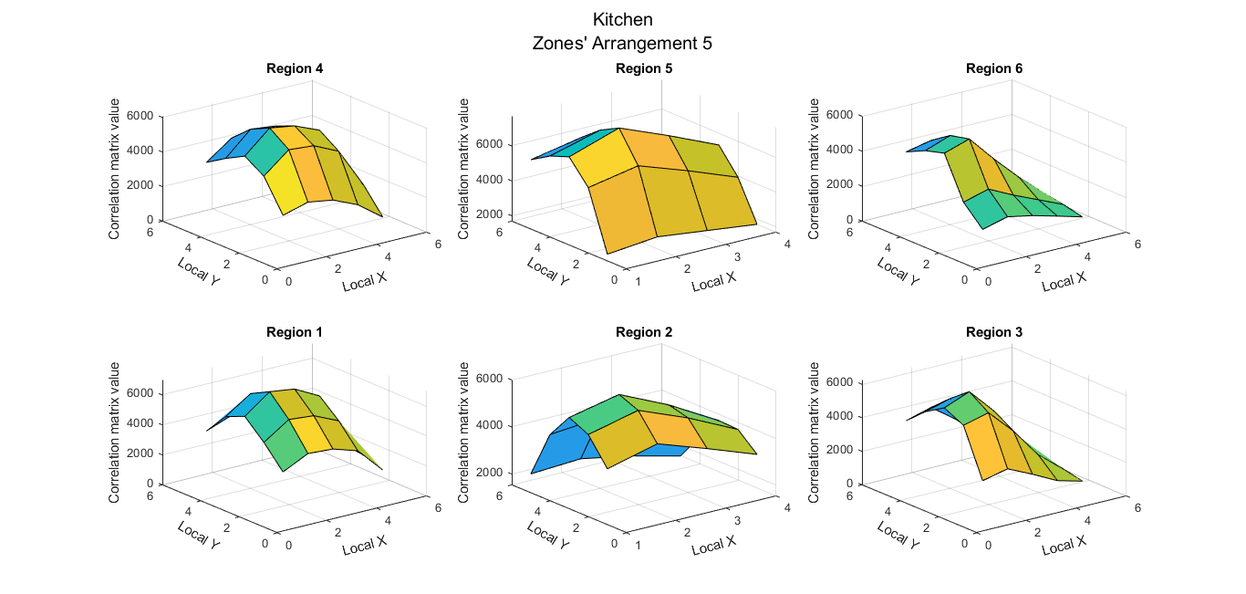

**ILLUMINATION ACROSS ROOM:**

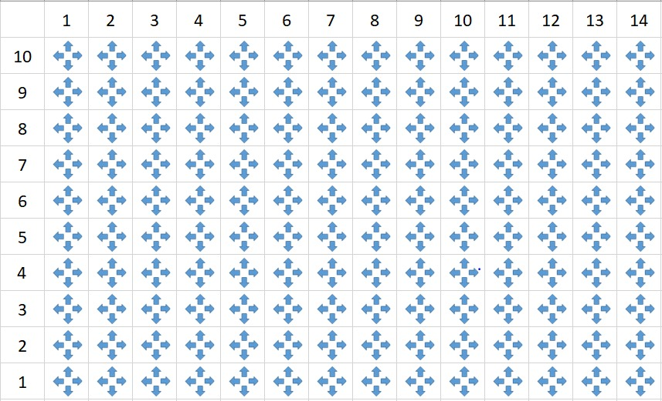

**ROOM: LIVING ROOM**

**BEST ARRANGEMENT OF ZONES and BEST LED POSITION:**

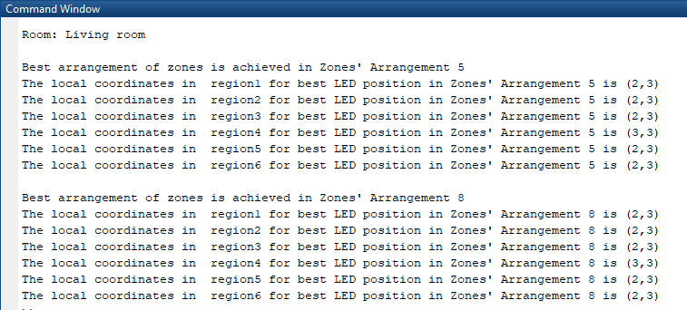

**Zones’ Arrangement 5**

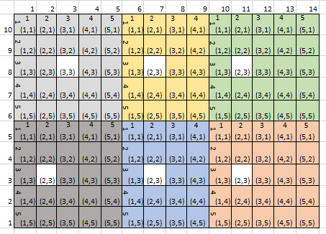

**Zones’ arrangement 8:**

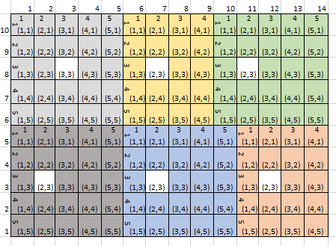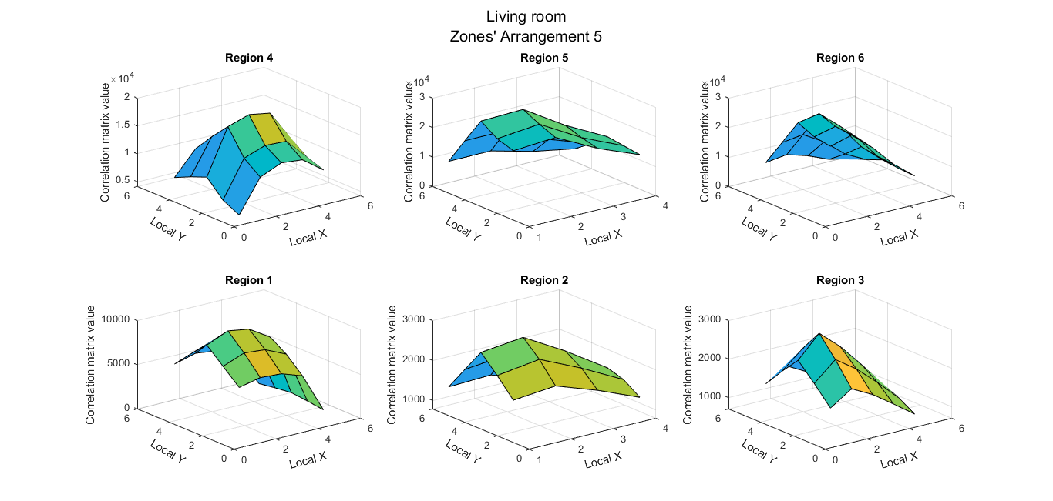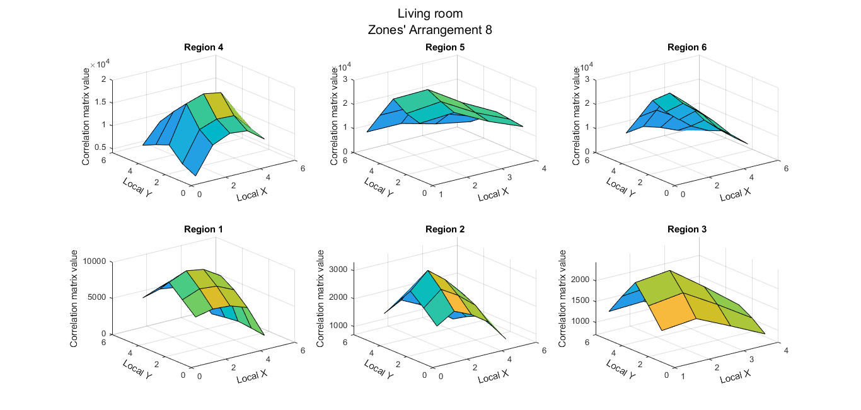

**ILLUMINATION ACROSS ROOM:**

**ZONES’ ARRANGEMENT 5:**



**ZONES’ ARRANGEMENT 8:**



**ROOM: BED ROOM**

**BEST ARRANGEMENT OF ZONES and BEST LED POSITION:**

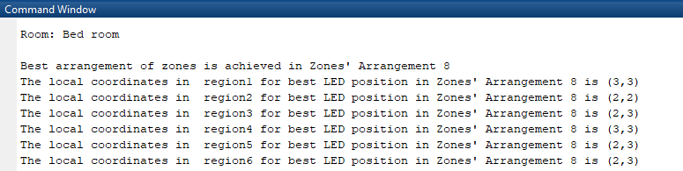

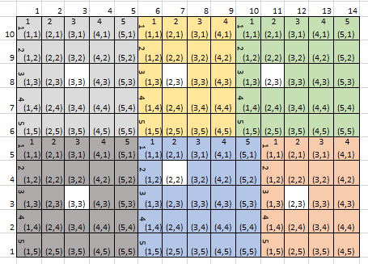

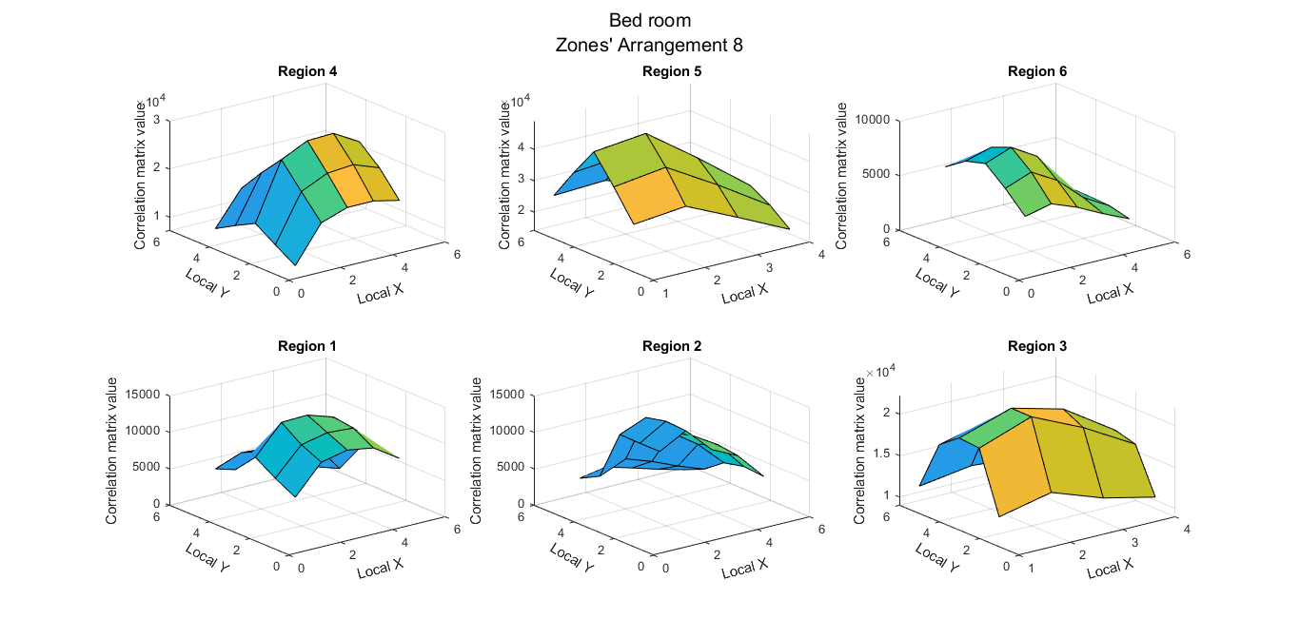

**ILLUMINATION ACROSS ROOM:**

**ARRANGEMENT 8: with all LEDs in their best position in respective zones, except LED of region 4.**

**LED of region 4, is in 2nd best possible position in region 4.**



**ROOM: OFFICE ROOM**

**BEST ARRANGEMENT OF ZONES and BEST LED POSITION:**

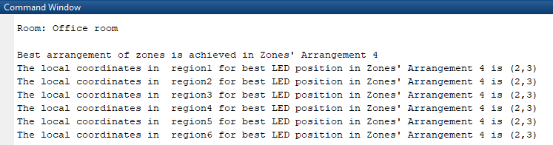

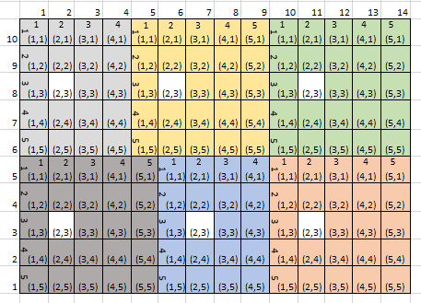

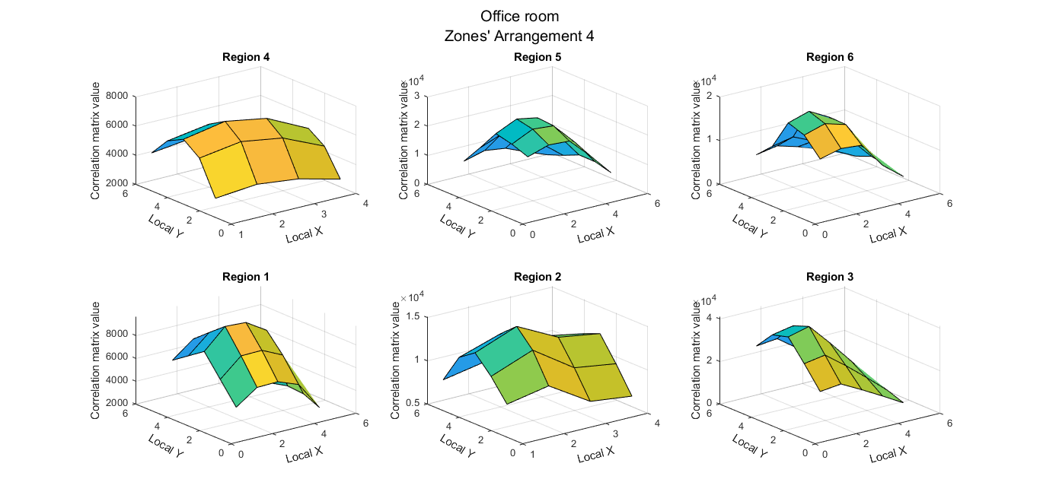

**ILLUMINATION ACROSS ROOM:**

